State Diagram – Tenant (Done by:Anisa Domi)
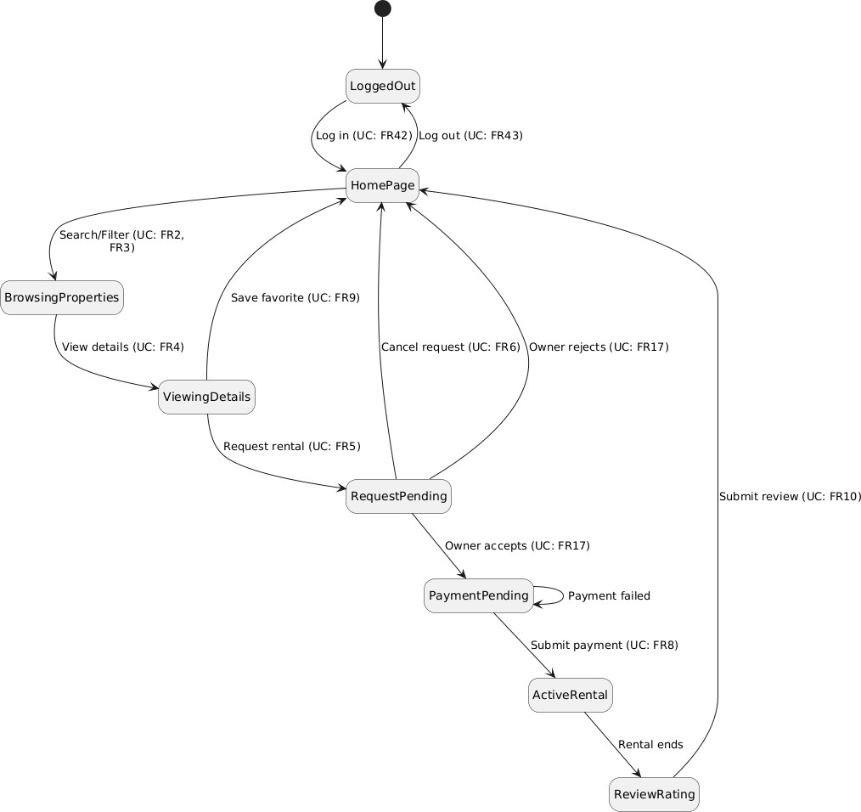

State Diagram - Property Owner (Done by:Haidi Toto)

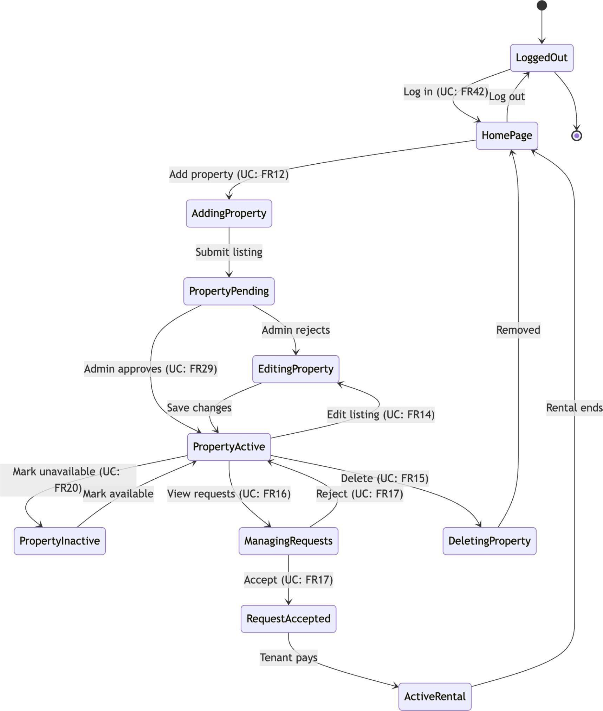

State Diagram – Administrator (Done by:Ledio Tafciu)

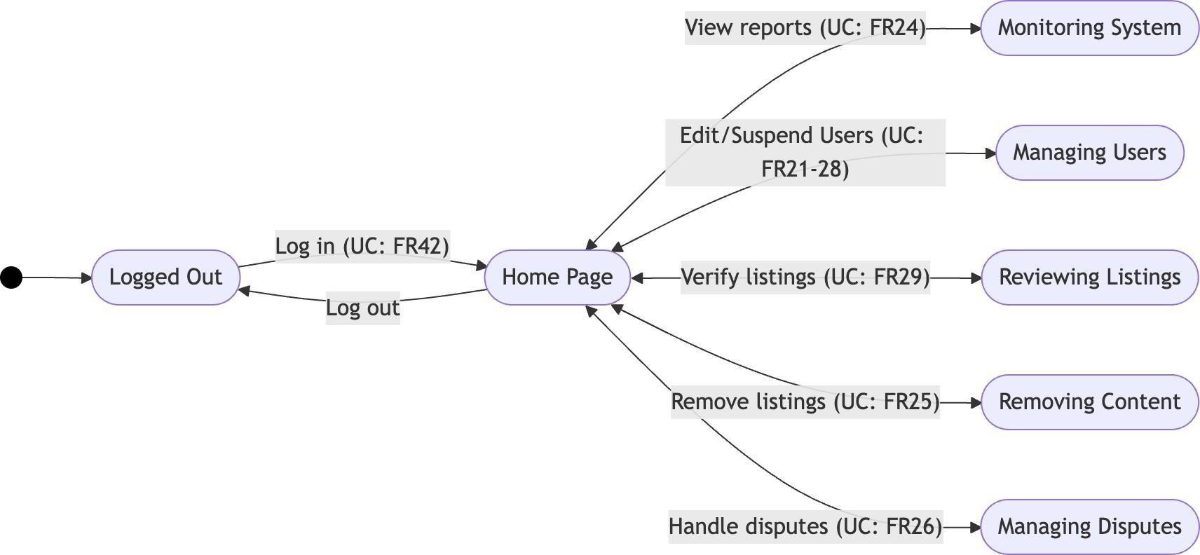

State Diagram – Manager (Done by: Matias Bali)
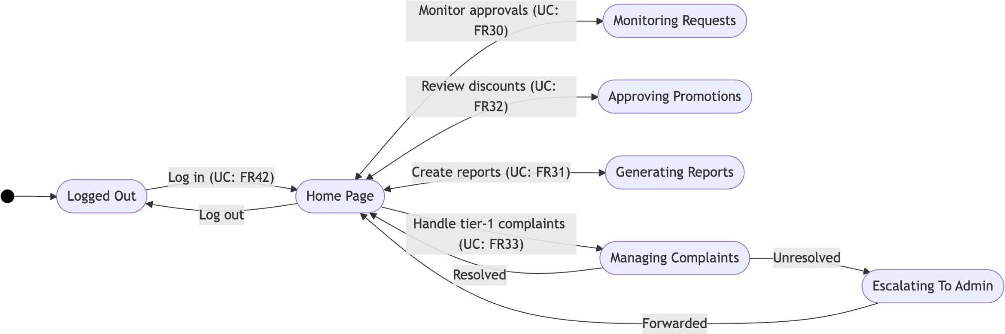

State Diagram – Financier (Done by:Ornelt Lemellari)
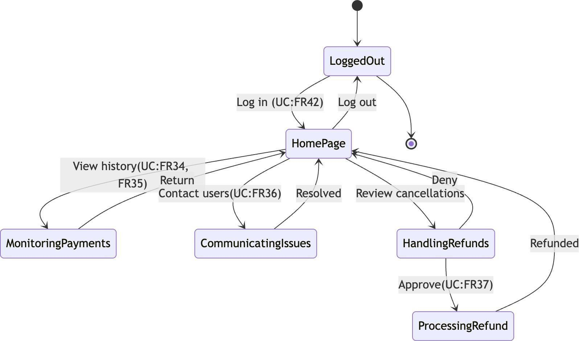

State Diagram – HR (Done by: Desard Lybeshari)
